FAX  Company Name  Street Address  City, ST ZIP Code  Phone  Website  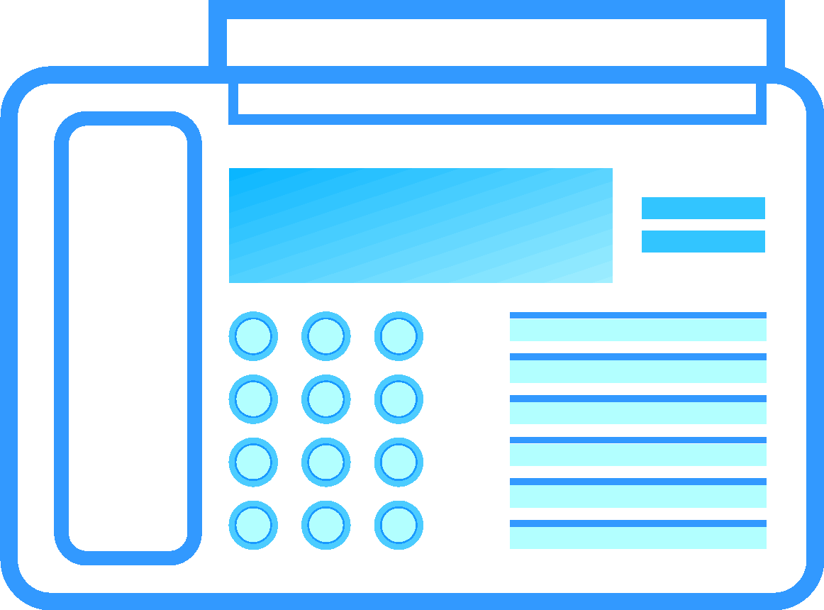 | To: Recipient Name  Fax number: Enter fax number  From: Your Name  Fax number: Enter fax number  Date: Enter date  Regarding:  Subject  Phone number for follow-up:  Phone

Comments:

